Dimpo Ehrens
600865
DevOps
Milestone 3

Docker practical exercise
Created docker-project directory
Created python script app.py
Created a Docker file
Bult and tagged the image and ran it.
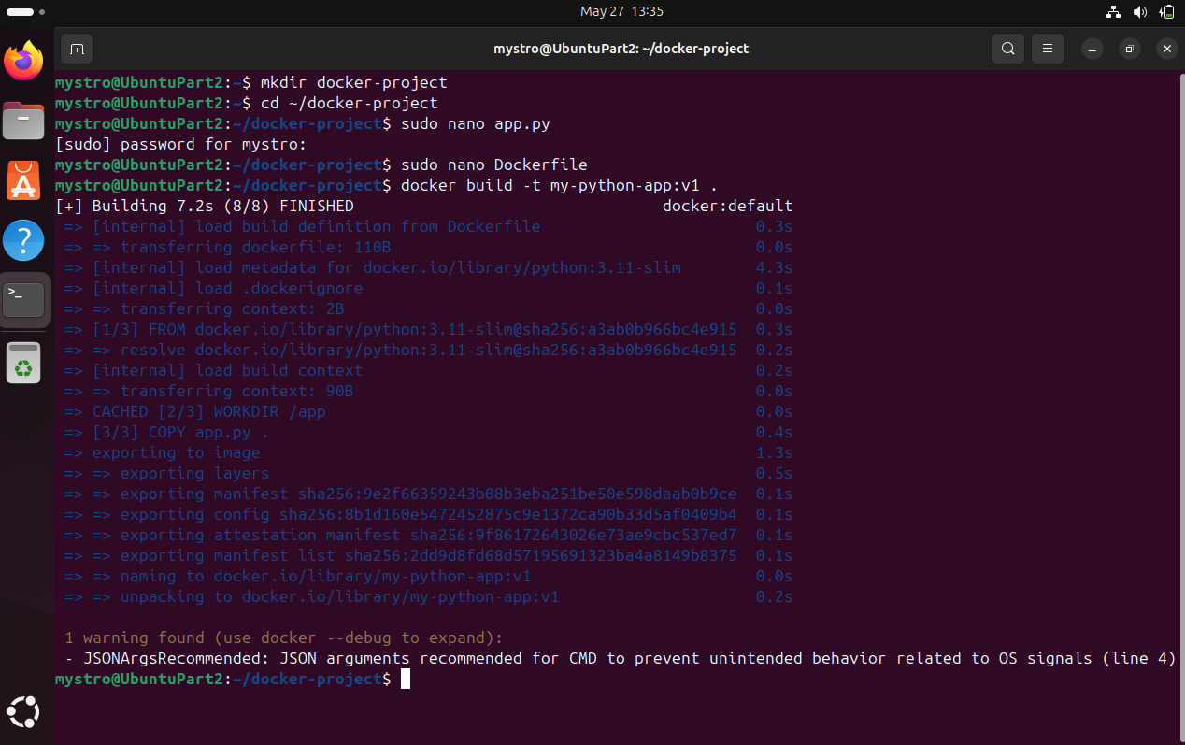
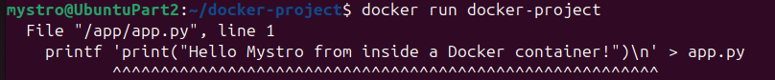

Git Practical Exercise
Created a project directory with python script. Proceeded to create a docker file, built and ran the container.

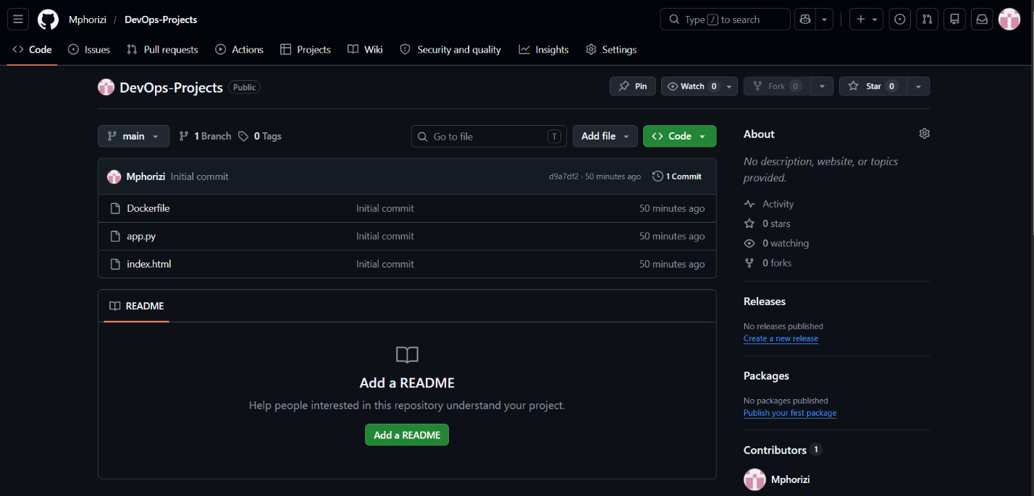
Chef Practical Exercise
Created a cookbook with recipes. Edited recipes/default.rb and ran the recipe locally.
